SX1018

Group Assignment

By: Stefan Rudvin, Rorie White, Ibrahim Ida

# Problem 1

1. Can we have an invalid argument and a true conclusion?

By definition the argument is valid if and only if there is no counterexample to the argument under any interpretation of the non-logical symbols occurring in it.

An invalid argument can have a true conclusion if the premises are false.

E.g. Mammals are cold blooded. Rabbits are mammals. Therefore, the earth is round.

In this example, the conclusion of an invalid argument is true is because it is independent of the truth of the premises.

1. Can a sound argument have a true conclusion?

By definition an argument is sound, just in the case where it is valid, and, in addition, the premises are true. Therefore, the conclusion of a sound argument must also be true.

E.g. The University of Aberdeen is in Scotland. Scotland is in Europe. Therefore, the University of Aberdeen is in Europe.

1. Can an unsound argument have a true conclusion?

Yes, because the truth of the conclusion can be independent of the validity of the argument and truth of the premises.

E.g. All humans are comedians. Jimmy Carr is human. Therefore, Jimmy Carr is a comedian.

In this example, the argument is invalid and the first premise is false. Still, the conclusion can be true.

1. Can a valid argument have false premises and a true conclusion?

Yes, a valid argument can have false premises and a true conclusion because logical validity is truth preservation in virtue of logical form, not the truth of the premises.

E.g. If Usain Bolt is a dog, he is the fastest man on earth. Usain Bolt is a dog. Therefore, he is the fastest man on earth.

1. Can an invalid argument have true premises and a true conclusion?

Yes. However, the truth is not guaranteed because the premises and the conclusion are not linked to each other in a logical argument.

E.g. Mammals are cold blooded. Rabbits are mammals. Therefore, the earth is round.

# Problem 2

# Problem 3

1. If A,B,C |= D and D |= E. Can we tell whether A,B,C |= E?

E is true because it follows the logical path that D is true if A,B and C are true. Since all the premises are true and the argument is valid, the conclusion must be true.

A,B,C |= D |= E

1. Suppose A,B,C |= D. Can we tell whether A,B |= D and if so is it true?

In this example, A,B |= D is true because any evaluation satisfying everything in A,B also satisfies D.

1. Suppose A,B |= D. Can we tell whether A,B,C |= D and if so is it true?

We can only tell if A,B,C |= D if any evaluation in C satisfies everything in A. Without knowledge of C we cannot be certain that A,B,C |= D.

1. Suppose A,B,C ̸|= D. Can we tell whether A,B |= D and if so is it true?

Without knowledge of the impact of the evaluations satisfying C we cannot be certain of the second statement. Also, A and B are contradictory expressions so A,B ̸|= D unless the premise of C would affect the outcome of A and B (which is not possible since they are separate premises).

1. Suppose A,B,C ̸|= D. Can we tell whether A,B,C ⊢ D and if so is it true?

Greg Restall’s book ‘Logic’ explains that both the tree method and the truth table method are sound. As X ⊢ A indicates that the completed tree for X closes, it is equivalent to the truth table expression X |= A. Therefore if A,B,C ̸|= D the expression A,B,C ⊢ D cannot be true.

# Problem 4

# Problem 5

# Problem 6

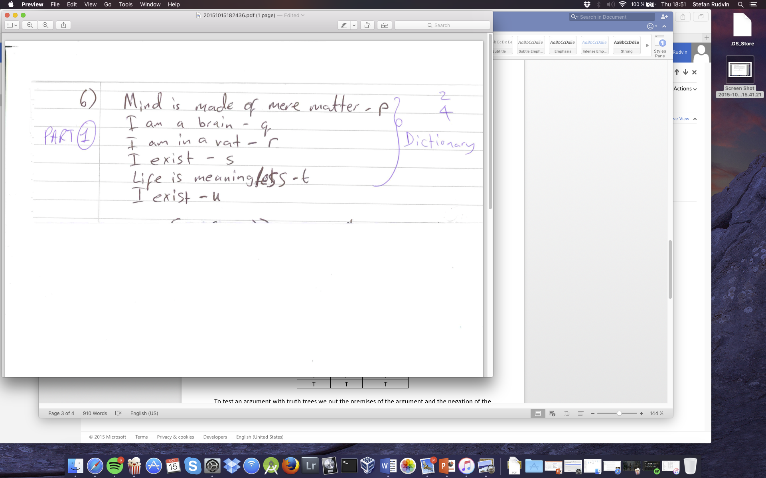

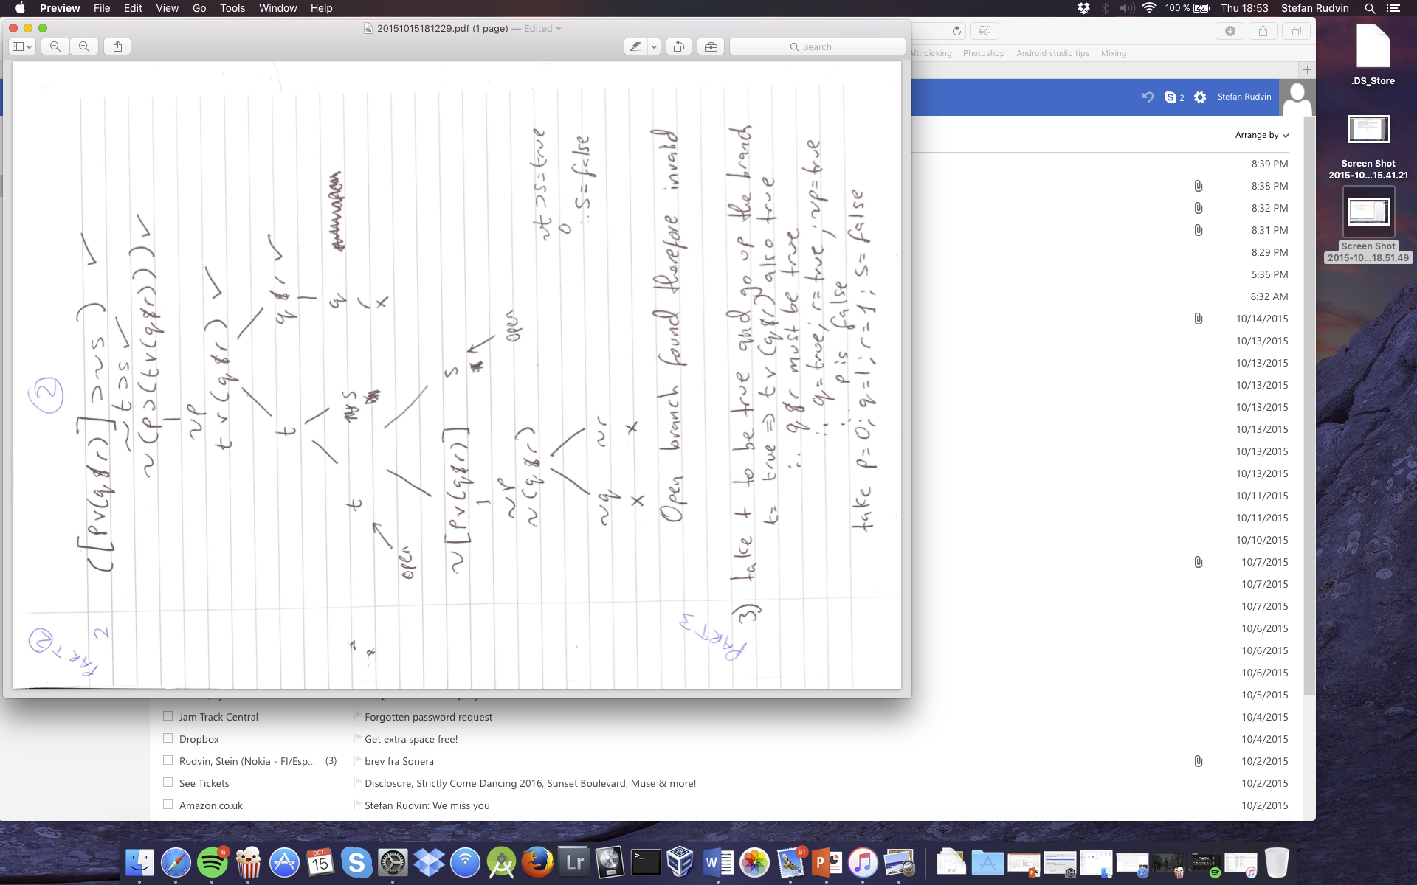

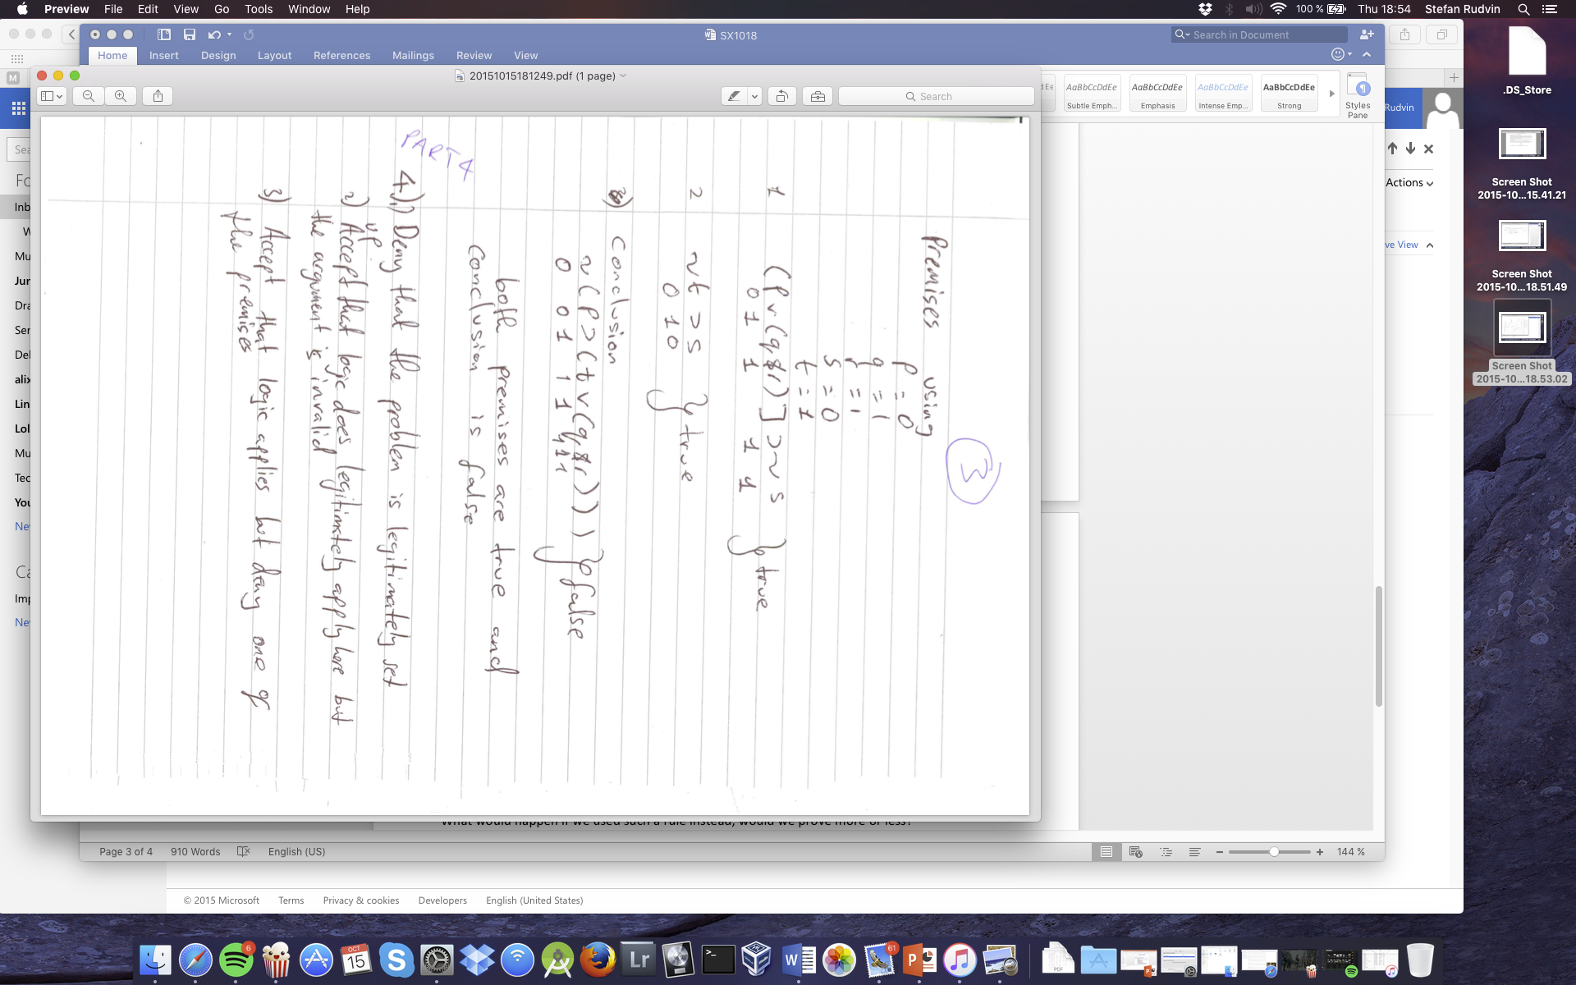

# 3. Challenge Question

Problem 8) There is a sense in which the tree technique for proof follows what happens in a truth table. Why then is there the case that we don’t use the following rule for disjunction?

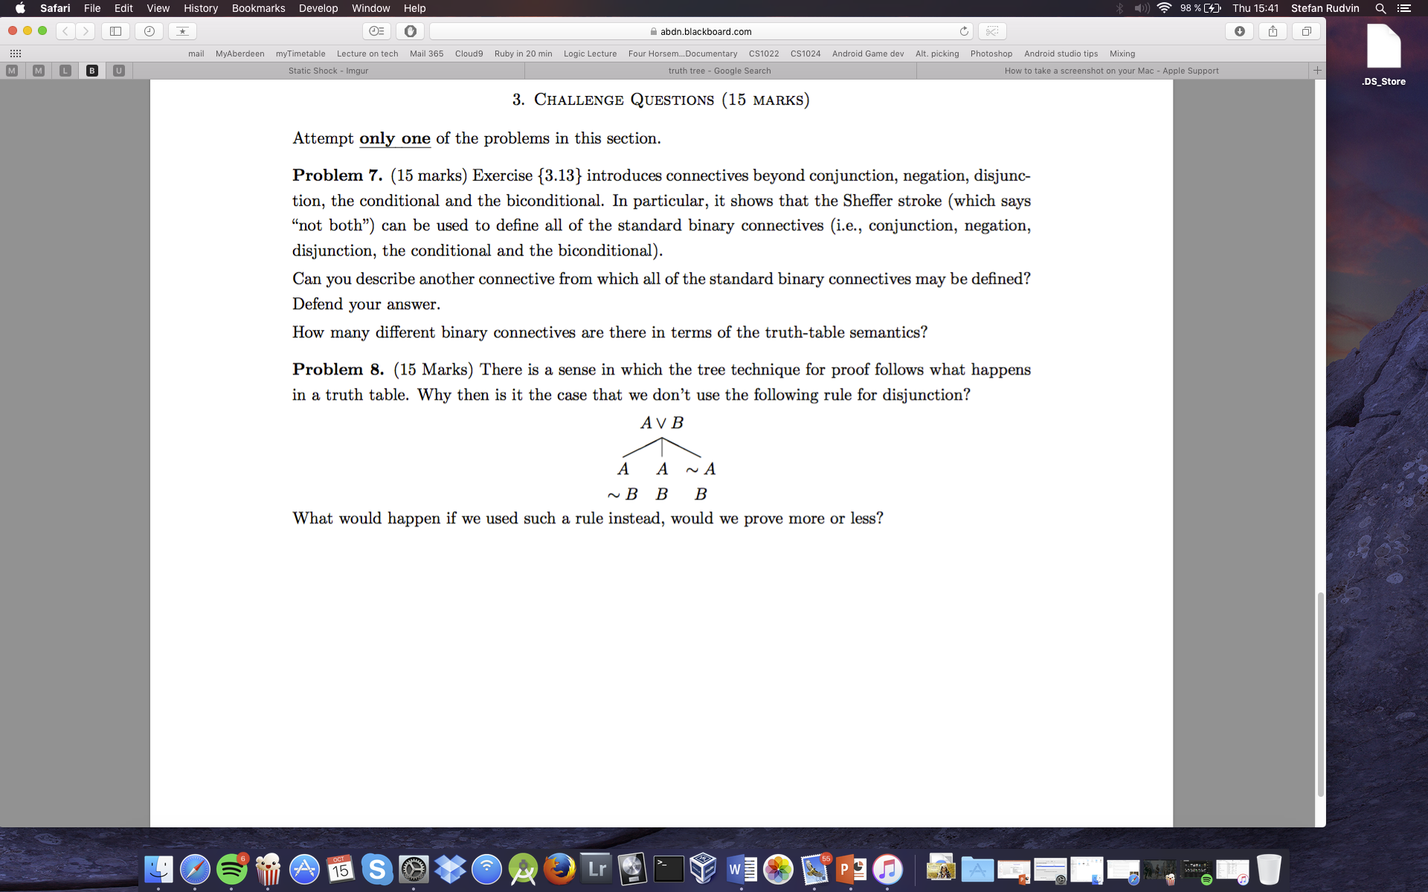

What would happen if we used such a rule instead, would we prove more or less?

The truth table below shows how A v B is only false when A and B are false.

|  |  |  |
| --- | --- | --- |
| **A** | **B** | **A v B** |
| F | F | F |
| F | T | T |
| T | F | T |
| T | T | T |

To test an argument with truth trees we put the premises of the argument and the negation of the conclusion in a list. Then we check if the list can be satisfied. If the propositions cannot be true together, the argument is valid; if they can be true together, the argument is invalid.

For A v B we have three evaluations of the atoms to satisfy the disjunction. The branch A is satisfied by (A = 1 and B = 0) and (A = 1 and B = 1) so it ‘uses’ two evaluations by itself. The branch B is satisfied by ( A = 0 and B = 1) and (A = 1 and B = 1) as well. Therefore, we can represent three evaluations by two open branches.

In the earlier example (A,B) satisfies the correct evaluations in (~A,B) and (A,~B). We can leave out the two latter evaluations since they are not required. Using trees with the disjunction rule will provide us with all the evaluations satisfying the formula, but it will not give us all of the ‘wrong’ evaluations.

*Definitions used from Greg Restall’s book Logic: An introduction, 2006.

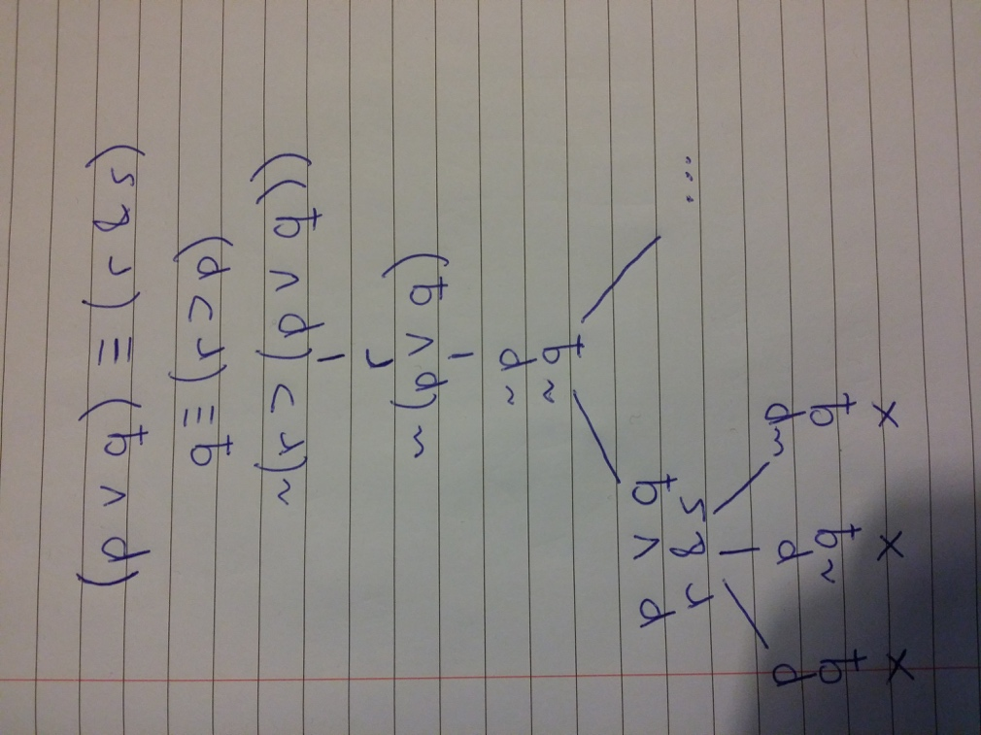Here is an example where using three branches gets no more satisfying evaluations than two.